Answer to The Question :1
- Shortest Job First is a CPU scheduling algorithm where the process with the smallest burst time (execution time) is selected to run next. Once the process starts executing it cannot be interrupt until it finishes. The scheduler selects the process with the shortest burst time among the available process.

- Waiting time (WT) =Turnaround Time (TAT) –Burst Time (BT)
Turnaround Time (TAT) = Completion Time (CT) – Arrival Time (AT)
Average Waiting Time (AWT) = (Sum of waiting time) / n
Average Waiting Time (AWT) = (Sum of Average Turnaround time) / n

- SJF reduces waiting time because shorter processes are executed first, so they do not wait behind longer processes.
In FCFS: Processes execute in order of arrival. A long process may block shorter ones.
In SJF: Short jobs finish earlier. This reduces the overall waiting time of processes, which results in lower average waiting time.

Answer to The Question :2
Given Processes,
Process | AT | BT
P1 | 0 | 6
P2 | 1 | 8
P3 | 2 | 7
P4 | 3 | 3

1.GANT CHART
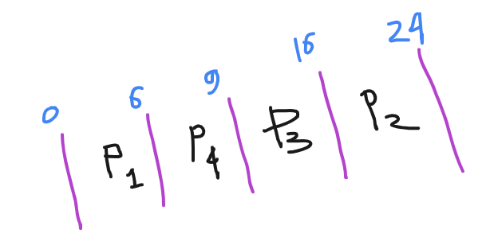

2. Calculate CT, TAT, WT
Process | AT | BT | CT | TAT | WT
P1 | 0 | 6 | 6 | 6 | 0
P2 | 1 | 8 | 24 | 23 | 15
P3 | 2 | 7 | 16 | 14 | 7
P4 | 3 | 3 | 9 | 6 | 3

3. Average Waiting Time (AWT) = (0+15+7+3) / 4 = 6.25
Average Waiting Time (AWT) = (6+23+14+6) / 4 = 12.25

Answer to The Question :3
#include <iostream>
using namespace std;

int main() {
int n, i, j, temp;

cout << "Enter number of processes: ";
cin >> n;

int bt[n], at[n], pid[n], wt[n], tat[n], ct[n];

for(i = 0; i < n; i++){
pid[i] = i + 1;
cout << "Enter arrival time and burst time for P" << i+1 << ": ";
cin >> at[i] >> bt[i];
}

for(i = 0; i < n-1; i++){
for(j = i+1; j < n; j++){
if(bt[i] > bt[j]){
temp = bt[i]; bt[i] = bt[j]; bt[j] = temp;
temp = at[i]; at[i] = at[j]; at[j] = temp;
temp = pid[i]; pid[i] = pid[j]; pid[j] = temp;
}
}
}

int current_time = 0;
float total_wt = 0, total_tat = 0;

for(i = 0; i < n; i++){
if(current_time < at[i])
current_time = at[i];

ct[i] = current_time + bt[i];
tat[i] = ct[i] - at[i];
wt[i] = tat[i] - bt[i];

current_time = ct[i];

total_wt += wt[i];
total_tat += tat[i];
}

cout << "\nP\tAT\tBT\tWT\tTAT\n";

for(i = 0; i < n; i++){
cout << "P" << pid[i] << "\t"
<< at[i] << "\t"
<< bt[i] << "\t"
<< wt[i] << "\t"
<< tat[i] << endl;
}

cout << "\nAverage Waiting Time = " << total_wt/n;
cout << "\nAverage Turnaround Time = " << total_tat/n << endl;

return 0;
}

Answer to The Question :4

Order by arrival
P1 -> p2 -> p3-> p4

FCFS Table
Process | AT | BT | CT | TAT | WT
P1 | 0 | 6 | 6 | 6 | 0
P2 | 1 | 8 | 14 | 13 | 5
P3 | 2 | 7 | 21 | 19 | 12
P4 | 3 | 3 | 24 | 21 | 18

AWT =(0 + 5 + 12 +18) / 4 = 8.75
ATAT = (6 + 13 + 19 + 21) = 14.75

- The Shortest Job First Scheduling (SJF) algorithm provides better performance.
- SJF runs the process with the shortest burst time first, so small jobs finish quickly. This helps reduce the average waiting time and turnaround time. But in First Come First Serve Scheduling (FCFS), processes run based on arrival order, so if a long job comes first, other processes have to wait longer.

